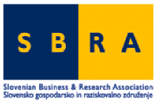 |   Autonomna Pokrajina Vojvodina | 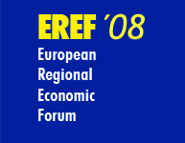

E R E F-2008 WORKSHOP
Novi Sad, 7 May 2008

Benefits and Opportunities of Participation in EU
Programmes for Countries of Western Balkans

AGENDA
Workshop-language: English

9.30 Welcome by Authorities of AP Vojvodina
Welcome by Executive Director of ECPD Negoslav Ostojić

9.45 Introduction to EREF by prof.Boris Cizelj, Director of Slovenian Business & Research Association, Brussels

  - Prof.Aleksandar Sedmak, Vice Rector, Belgrade university:
Experience with Framework Programmes and Opportunities for the Region

  - Prof.Boris Cizelj:
Opportunities and Benefits of EU Programmes

  - Dr.Gilbert Fayl/Ulric von Hentaller:
Involving Academia and Business

- Leonardo Piccinetti:
Information Sources on EU Programmes

  - Discussion

- Conclusions and Closing

  - Networking Lunch offered by Vojvodina Regional Government

