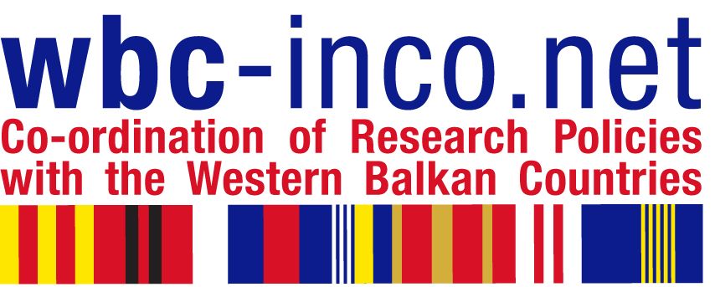

TRAINING PROGRAMME FOR RESEARCH MANAGERS

Organized in the framework of WBC-INCO:NET Project (www.wbc-inco.net) by Slovenian Business & Research Association in collaboration with Serbian Economic Chamber, Ministry of Science, and European Centre for Peace and Development

8 May 2008

Serbian Economic Chamber, Resavska 13-15, 11000 Belgrade,

Introductory Seminar with dr.Sean McCarthy "How to Write a Competitive Proposal for
Framework Programme, FP7"

Seminar Programme:

10.00 Welcome by the Serbian Economic Chamber
Opening address by Mr.Victor Nedović, Deputy Minister for Science and Environment,
Prof.dr.Boris Cizelj: Introduction to EU Programmes

10.30 - 11.30 Dr.Sean McCarthy: The Fundamentals of Framework Programme 7

- structure of Framework 7
- how proposals are evaluated
- different funding schemes (grants)
- which countries can participate

Coffee Break

12.00 - 13.00 How to Write a Competitive Proposal for Framework 7
- the one page proposal
- how to streamline proposal writing.

13.00 - 14.30 Sandwich Lunch offered by Serbian Economic Chamber

WBC-INCO.NET Training Workshop for research managers from companies and research establishments

Workshop Programme:

14.00 - 15.30 dr.Sean McCarthy: Managing Project preparation, Definition of Deliverables, and Consortium Building

Coffee Break

16.00 - 17.00 dr.Sean McCarthy: Budgeting and Reporting

17.00 - 17.30 Leonardo Piccinetti: FP7 Information Sources

