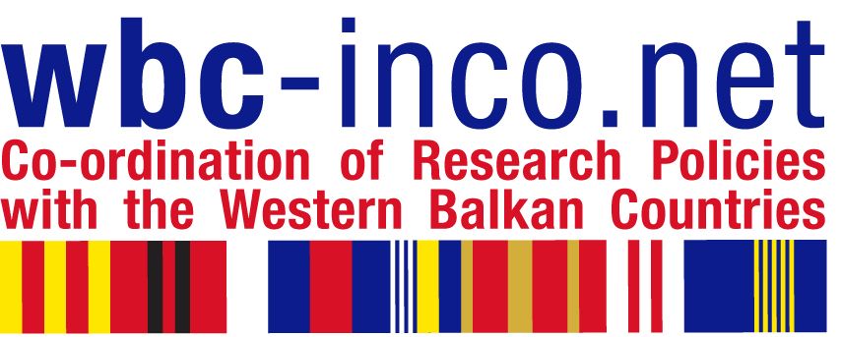

INVITATION

TRAINING PROGRAMME FOR RESEARCH MANAGERS

organized in the framework of WBC-INCO.NET Project (www.wbc-inco.net )
by Slovenian Business and Research Association in collaboration with Academy of Science and Arts of Bosnia and Herzegovina, Sarajevo

9 May 2008, Bistrik 7, Sarajevo

Introductory seminar with dr.Sean McCarthy:
"How to Write a Competitive Proposal for Framework Programme, FP7"

Seminar Programme:

10.00 – 10.30 Welcome by prof.dr.Miloš Tričković, Academy of Science and Arts of Bosnia and Herzegovina
Mr.Osman Topčagić, Director of Directorate for European Integration - Bosnia and Herzegovina on its Integration Road to EU
Prof.dr.Boris Cizelj: Introduction to EU Funding Programmes
Ammar Mirašćija: The Experience of Bosnia and Herzegovina in Framework Programmes

10.30 - 11.30 dr.Sean McCarthy: The Fundamentals of Framework 7
- structure of Framework 7
- how proposals are evaluated
- different funding schemes (grants)
- which countries can participate

Coffee Break

12.00 - 13.00 How to Write a Competitive Proposal for Framework 7
- the one page proposal
- how to streamline proposal writing.

13.00 - 14.00 Sandwich Lunch offered by Academy of Science and Arts, BIH

WBC-INCO.NET Training Workshop for research managers from academies, research establishments, universities, and companies

Workshop Programme:

14.00 - 14.30 dr.Gilbert Fayl: Involving Academies
14.30 - 15.30 dr.Sean McCarthy: Managing Project preparation, Definition of Deliverables and Consortium Building.

Coffee Break

16.00 - 17.00 dr.Sean McCarthy: Budgeting, Reporting
17.00 - 17.30 Leonardo Piccinetti: FP7 Information Sources

